
Viewed by:
Philippe POHER
Tel.: +33 (0)2 99 27 92 92
E-mail: Philippe.POHER@iwedia.com

Written by:
Philippe POHER
Tel.: +33 (0)2 99 27 92 92
E-mail: Philippe.POHER@iwedia.com
IWEDIA

TDAL_DMX Technical Specifications

V2.3

Approved by:
Thierry GARNIER
Tel.: +33 (0)2 99 27 92 92
E-mail: thierry.garnier@iwedia.com

SUMMARY
1 Reference documents 4
2 Documentation History 5
3 Introduction 6
4 Module Overview and Architecture 7
4.1 Definitions, Acronyms and Abbreviations 7
4.2 General Description 8
4.2.1 Limitations 8
4.2.2 Demultiplexer instances Use 9
4.2.2.1 Basic Zapper 9
4.2.2.2 PVR Case 9
4.2.2.3 Demux identifiers 10
4.2.3 Filtering Section Information 11
4.2.3.1 Positive filtering Mode 11
4.2.3.2 Negative Filtering Mode 11
4.2.4 Interactions with other TDAL modules 13
4.2.4.1 Interaction with TDAL_AV module 13
4.3 Architecture 13
4.4 TDAL_DMX API Description 14
4.4.1 Generic Interface 14
4.4.2 Demux Instances Interface 14
4.4.3 Channel Interface 14
4.4.4 Filter Interface 14
5 TDAL_DMX API Specification 15
5.1 Type Specifications 15
5.1.1 Generic 15
5.1.2 Demux Instances Interface 15
5.1.3 Channel Interface 15
5.1.4 Filter Interface 15
5.2 TDAL_DMX API Usage 16
5.2.1 Initialisation 16
5.2.2 Section Filtering Processing 17
5.2.3 PES teletext (TTXT_OSD) filtering 18
5.2.4 PES Subtitle filtering 19
5.2.5 Audio/Video Filtering 20
5.2.6 Audio Description Case 21
5.3 TDAL_DMX Macro/Define/Enum/Typedef/Structure Definitions 22
5.3.1 Define Definitions 22
5.3.1.1 kTDAL_DMX_ILLEGAL_DEMUX 22
5.3.1.2 kTDAL_DMX_ILLEGAL_CHANNEL 22
5.3.1.3 kTDAL_DMX_ILLEGAL_FILTER 22
5.3.1.4 kTDAL_DMX_ILLEGAL_PID 22
5.3.2 Enum Definitions 23
5.3.2.1 tTDAL_DMX_Error 23
5.3.2.2 tTDAL_DMX_DemuxId 23
5.3.2.3 tTDAL_DMX_Ctrl 24
5.3.2.4 tTDAL_DMX_ChannelStream 24
5.3.2.5 tTDAL_DMX_ChannelOutput 24
5.3.2.6 tTDAL_DMX_ChannelMemorySize 25
5.3.3 Typedef Definitions 26
5.3.3.1 tTDAL_DMX_ChannelId 26
5.3.3.2 tTDAL_DMX_FilterId 26
5.3.3.3 tTDAL_DMX_ChannelCallbackFct 26
5.3.4 Structure Definitions 27
5.3.4.1 tTDAL_DMX_ChannelType_t 27
5.4 TDAL_DMX API Functions 28
5.4.1 Generic Interface API 28
5.4.1.1 TDAL_DMX_Init(-) 28
5.4.1.2 TDAL_DMX_Terminate(-) 29
5.4.1.3 TDAL_DMX_APIRevisionGet(-) 30
5.4.1.4 TDAL_DMX_PlatformRevisionGet(-) 31
5.4.1.5 TDAL_DMX_GetDemuxId(-) 32
5.4.1.6 TDAL_DMX_Allocate_Channel(-) 33
5.4.1.7 TDAL_DMX_Register_Channel_Callback(-) 34
5.4.1.8 TDAL_DMX_Free_Channel(-) 35
5.4.1.9 TDAL_DMX_StreamHandleGet(-) 36
5.4.1.10 TDAL_DMX_Set_Channel_PID(-) 37
5.4.1.11 TDAL_DMX_Control_Channel(-) 38
5.4.1.12 TDAL_DMX_Allocate_Filter(-) 39
5.4.1.13 TDAL_DMX_Free_Filter(-) 40
5.4.1.14 TDAL_DMX_Set_Filter(-) 41
5.4.1.15 TDAL_DMX_Control_Filter(-) 43
5.4.1.16 TDAL_DMX_Free_Buffer(-) 44
6 TDAL_DMX External Dependencies 45
6.1.1.1 tTDAL_DMX_ChannelCallbackFc 45

Reference documents
The following documents were used to write this specification:

Document | Version | Title
TDAL_AV | 1.5 | TDAL_AV specification
ETSI EN 300 468 | V1.8.1 | Digital Video Broadcasting specification for Service Information in DVB Systems
TDAL_TS | 1.0 | TDAL_TS specification

Documentation History

History
Vers. | Date | Nature
2.0 | 07/01/2007 | PPO: First version of relook of TDAL_DMX
2.1 | 11/01/2007 | GS : Precise demultiplexer instances use chapter in PVR case.
2.2 | 21/10/2008 | DUF : add comment fot the callback ChannelCallbackFc
2.3 | 06/04/2009 | Add explanation for TDAL_DMX_Set_Channel_PID  Add explanation for tDAL_DMX_ChannelCallbackFc

Introduction
The purpose of this document is to specify the interface and to describe the internal design of the Thin Driver Adaptation Layer for Demultiplexer [TDAL_DMX]. The aim of this module is to provide a complete interface between middlewares and the demulitplexer stage low level driver of a set-top-box.

Module Overview and Architecture

Definitions, Acronyms and Abbreviations
CHAL | Comedia hardware Adaptation Layer, composed of TDALs driver, TKEL and TBOX module
TDAL | Thin Driver Adaptation Layer
TKEL | Thin Kernel Encapsulation Layer
TBOX | Tool Box
Channel | “Slot” in demultiplexer in which a row TS data associated to PID is filtered
PID | Packet identifier
Filter | Mask applied on channel to filter specific data amount (section or PES).
PES | Packet Elementary Stream
ES | Elementary Stream

General Description
The main job of the TDAL_DMX is to manage demultiplexing for audio/video components, PES and section filtering.
The TDAL_DMX is in charge to manage demulitplexer resources (channel, filter, PID), according to the client request.
The TDAL_DMX must be designed for multi-client calls.
For section filtering, the TDAL_DMX module must manage a memory pool, since the comedia middleware doesn’t copy filtered sections in its memory pool (TKEL) for performance reason.
For teletext PES filtering (TTXT OSD) and subtitle filtering, the TDAL_DMX must manage a memory pool, since the comedia middleware doesn’t copy filtered pes in its memory pool (TKEL) for performance reason.

PES or section
Demux instance
F
Channel 0 pid 0
TS input
AV Decoder
F
Channel 1 pid 1

ES
F
Filter

Limitations
The following limitations for the client have been defined:
- A Pid already set to a channel resources can’t be applied to another channel
- One Decoder Video, one decoder audio may be connected to a demultiplexer instance
- Many filter may be create for a channel.

Demultiplexer instances Use
The demultiplexer module is multi-intance in order to cope with PVR and /or multi-stream decoding platform capabilities.

Basic Zapper
At least, one demux instance is mandatory for basic zapper. 2 demux instances are mandatory for dual decode zapper.

PVR Case
Watch Live Program case:
The end-user watches a program. At least, two demux instances are mandatory:
- One demux instance is used to extract the elementary streams of watched program into a TS packet memory buffer Only section filtering, PCR filtering are done by TDAL_DMX on this demux. The elementary streams PID extraction is managed by TDAL_TS (see [TDAL_TS] document for more details).
- The second demux instance is feed by a kind of software TS input with the previous extracted TS memory buffer. This injection is handled by TDAL_TS (see [TDAL_TS] document for more details). The elementary streams filtering output result (controlled by TDAL_DMX) of this demux instance feeds the different hardware (audio, video) and software (subtitle, teletext, …) decoders.
One Record case:
If the user wants to record the watched program, the TS packet memory buffer is transferred on a mass storage device. This transfer is handled by TDAL_TS (see [TDAL_TS] document for more details). If it is only a record without display, the second demux does not filter anything.
This model allows to have a smooth “live one touch record” without TS path reconfiguration.
Two records case:
Three demultiplexer instances are needed. It is the same model as the “Watch Live Program case” and “One Record cases” for the first two demuxes.
The third demux is used to extract a scheduled record progam into a TS packet memory buffer which is transferred on a mass storage device.
In “watch’n’ record” scenario and due to possible user record need sequences, the two demuxes dedicated to TS extraction can be used alternatively to filter PCR and section data.

Demux identifiers
The TDAL_DMX interface has reserved three demux instance identifiers: 0, 1 and 2.
The identifier 0 is dedicated to the demux instance which feeds the different hardware (audio, video) and software (subtitle, teletext, …) decoders. For a basic zapper, it is also used for section data extraction.
The identifiers 1 and 2 are dedicated to demux instances that extract the elementary streams in the PVR case.

Filtering Section Information
To filter section, two modes are available: The positive filtering mode and the negative filtering mode.
These modes are defined for each bit of the filter value and may be mixed.
The following information are used to set a filtering process:
Filter: The value to check for section filtering
Mask: The bit to check in filter value
Mode: The filtering mode to apply on the mask (positive or negative).

Positive filtering Mode
The client may request to filter section with specific data:
TableId, extensionId, version number …
This specific data are given thanks to the TDAL_DMX API of filter ressource: TDAL_DMX_set_filter.
The filter processing will filter and give the copy of section which matches with the specific data requested by client.

Negative Filtering Mode
When a client has already got a section, it may request a new filtering process to get next version of the section get. Thus, the client creates a filter ressource and set filter in negative filtering mode. The filter processing will filter and give copy of section, which not match with the specific version number given by the client.

If the low level of the demultiplexer driver is not able to process negative filtering mode, the TDAL_DMX design will have to be done to implement a software filtering to provide the negative filtering mode function.

Example1: Positive filtering mode on table id and Extension Id.
Filter: 0x42 0x00 0x02 0x00 0x00 0x00 0x00 0x00
Mask: 0XFF 0XFF 0XFF 0X00 0X00 0X00 0x00 0x00
Mode: 0XFF 0XFF 0XFF 0X00 0X00 0X00 0x00 0x00

All sections with TableId 0x42 and extensionId 0x0002 will be filtered.

Example1: Negative filtering mode on version number.
Filter: 0x42 0x00 0x02 0x02 0x00 0x00 0x00
Mask: 0XFF 0XFF 0XFF 0X3E 0X00 0X00 0X00
Mode: 0XFF 0XFF 0XFF 0XC1 0X00 0X00 0X00

All sections with TableId 0x42, extensionId 0x0002, and version number different than 0x01 will be filtered.

Interactions with other TDAL modules
TDAL_DMX may be interfaced with other TDALs:

Interaction with TDAL_AV module
TDAL_AV needs an access to the input stream of TDAL_DMX to indicate from which video or audio demultiplexer channel, the input stream is received.
For that purpose and to have a complete independence between the TDAL_DMX, TDAL_AV and other TDAL APIs, the notion of stream handle is used. The stream handle is an unique opaque value that is used as accessor to a specific video or audio stream. This handle is used transversely between the different TDAL modules in order to authorize a TDAL module to access the low level driver that manages the video or audio streams.
The client is able to get the audio and video stream handle with the call of function TDAL_DMX_GetStreamHandle(-) with the audio and video channel identifier.
This handle will be set to TDAL_AV. The client doesn’t know really what is masked under the opaque value of stream handle.

Architecture
The figure below shows the relation between the client module and the low level drivers:
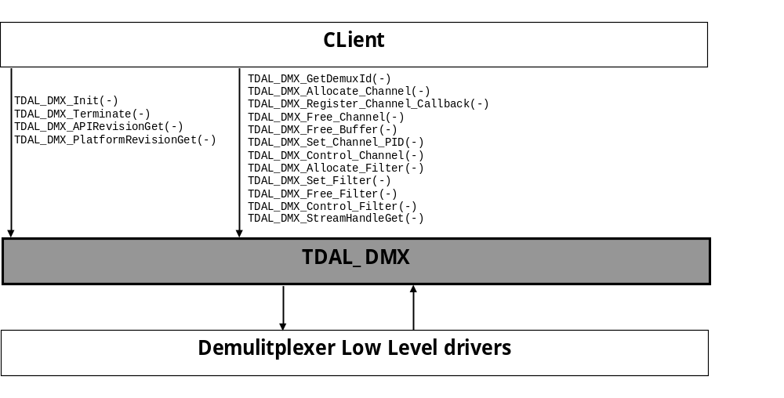

TDAL_DMX API Description

Generic Interface
The generic interface allows clients to control the TDAL_DMX module.
This interface is used with the following functions:
- TDAL_DMX_Init(-) in order to initialise the TDAl_DMX module
- TDAL_DMX_Terminate(-) in order to terminate the TDAL_DMX module
- TDAL_DMX_APIRevisionGet(-) in order to get revision
- TDAL_DMX_PlatformRevisionGet(-) in order to get the platform revision

Demux Instances Interface
- TDAL_DMX_GetDemuxId(-) in order to get demux capabilities.

Channel Interface
- TDAL_DMX_Allocate_Channel(-) in order to allocate a channel for pes/es/section filtering
- TDAL_DMX_Register_Channel_Callback(-) in order to register channel callback to get section or pes buffer TDAL_DMX_Free_Channel(-) in order to free a channel.
- TDAL_DMX_Set_Channel_PID(-) in order to set a PID on a channel.
- TDAL_DMX_Control_Channel(-) in order to start channel filtering
- TDAL_DMX_StreamHandleGet(-) in order to get stream handle
- TDAL_DMX_Free_Buffer(-) in order to free a filtered (PES, section) buffer.

Filter Interface
- TDAL_DMX_Allocate_Filter(-) in order to allocate a filter set on an allocated channel
- TDAL_DMX_Set_Filter(-) in order to the client gives filtering settings.
- TDAL_DMX_Free_Filter(-) in order to free a filter set.
- TDAL_DMX_Control_Filter(-) in order to start filter processing.

TDAL_DMX API Specification

Type Specifications

Generic
tTDAL_DMX_Error defines error values detected by tdal_dmx functions.

Demux Instances Interface
tTDAL_DMX_DemuxId is used to define demux instance identifier.

Channel Interface
tTDAL_DMX_Ctrl defines control commands on channel filtering processing.
tTDAL_DMX_ChannelStream defines the value of channel use (audio, video, subtitle, section filtering)
tTDAL_DMX_ChannelOutput defines the target of the channel filtering (decoder or memory area in TDAL_DMX memory pool)
tTDAL_DMX_ChannelMemorySize defines for section and pes filtering the maximal size of buffer filtering.
tTDAL_DMX_ChannelCallbackFct defines the prototype of the client callback to receive PES and section filtered buffers.
tTDAL_DMX_ChannelType_t is defined to give the channel settings:
- tTDAL_DMX_ChannelStream
- tTDAL_DMX_ChannelOutput
- tTDAL_DMX_ChannelMemorySize

Filter Interface
tTDAL_DMX_Ctrl defines the control command on filter processing

TDAL_DMX API Usage

Initialisation
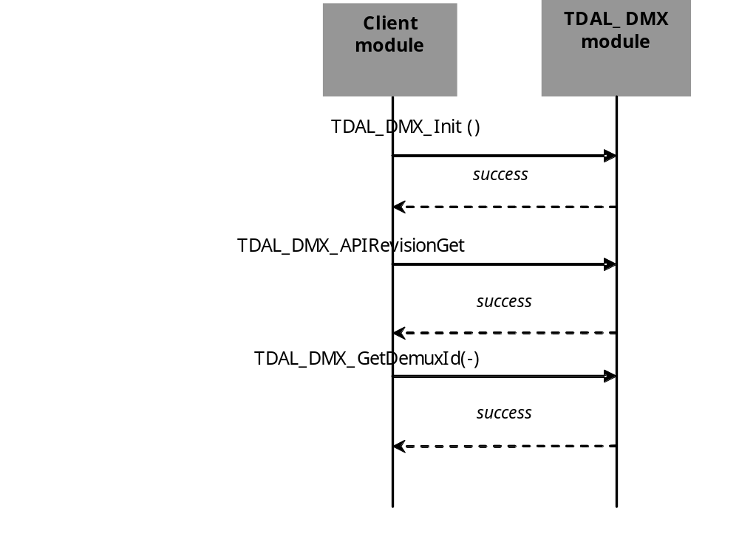

Section Filtering Processing
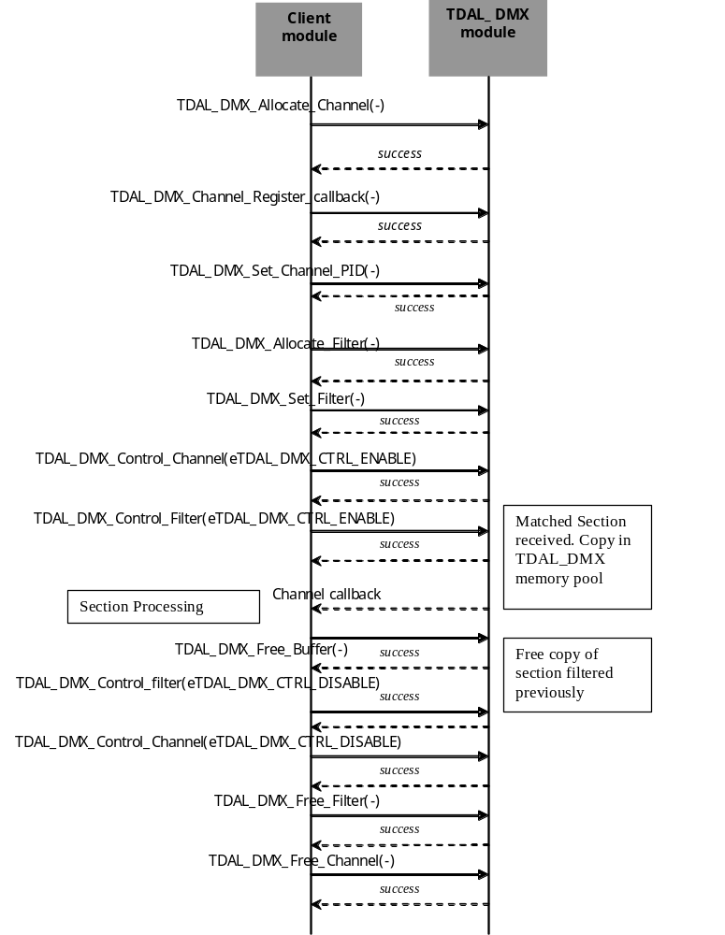

PES teletext (TTXT_OSD) filtering
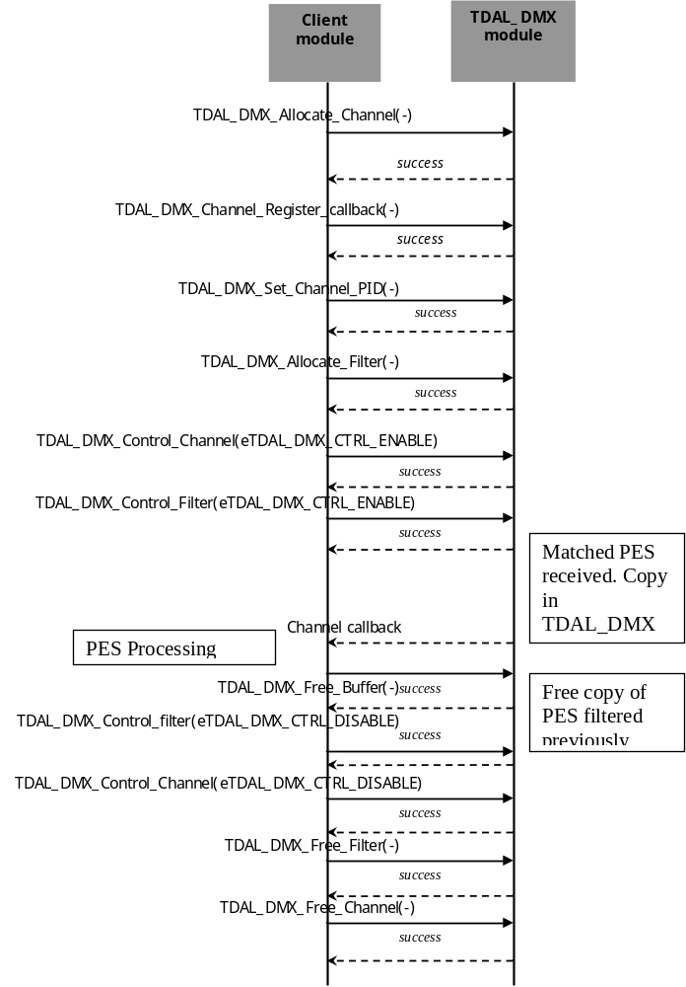

PES Subtitle filtering
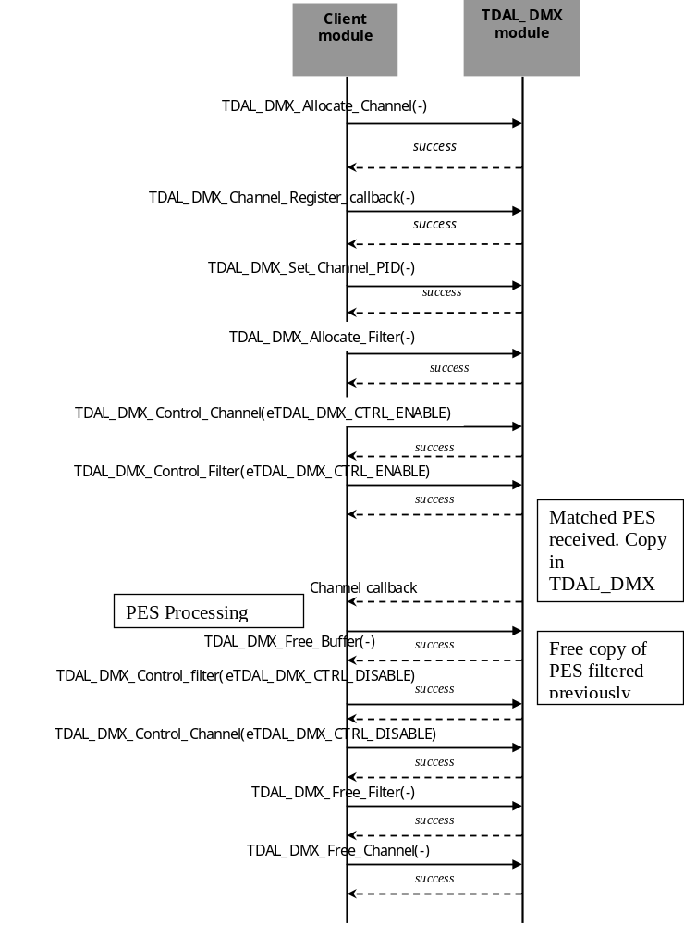

Audio/Video Filtering
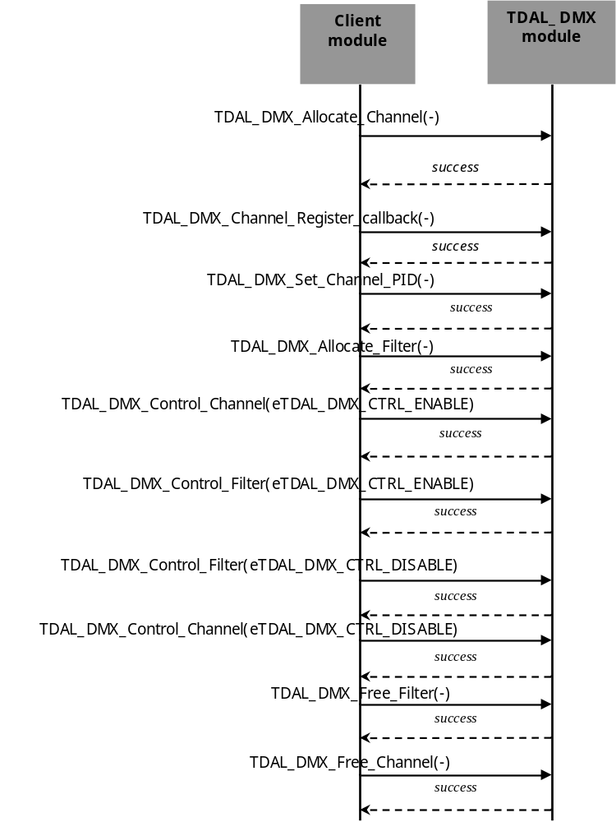

Audio Description Case
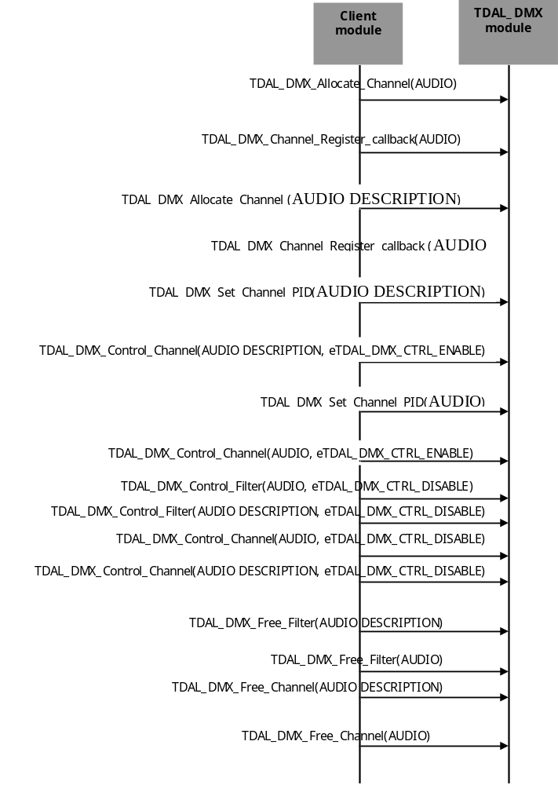

TDAL_DMX Macro/Define/Enum/Typedef/Structure Definitions

Define Definitions

kTDAL_DMX_ILLEGAL_DEMUX
This constant is used to define the illegal value for demux Id
#define kTDAL_DMX_ILLEGAL_DEMUX (-1)

kTDAL_DMX_ILLEGAL_CHANNEL
This constant is used to define the illegal value for Channel Id
#define kTDAL_DMX_ILLEGAL_CHANNEL (-1)

kTDAL_DMX_ILLEGAL_FILTER
This constant is used to define the illegal value for Filter Id
#define kTDAL_DMX_ILLEGAL_FILTER (-1)

kTDAL_DMX_ILLEGAL_PID
This constant is used to define the illegal value for PID
#define kTDAL_DMX_ILLEGAL_PID (-1)

Enum Definitions

tTDAL_DMX_Error
It is an enumeration of the different possible error value handled by TDAL_DMX.
typedef enum
{
kTDAL_DMX_NO_ERROR = 0, /* no error */
kTDAL_DMX_ERROR_BAD_PARAMETERS, /* bad parameter in function call */
kTDAL_DMX_ERROR_UNABLE_TO_GRANT,
kTDAL_DMX_ERROR_TOO_MANY_REQ, /* too many request already active */
kTDAL_DMX_ERROR_INVALID_DEMUX_ID, /* invalid demux id */
kTDAL_DMX_ERROR_INVALID_CHANNEL_ID, /* invalid channel id */
kTDAL_DMX_ERROR_INVALID_FILTER_ID, /* invalid filter id */
kTDAL_DMX_ERROR_CANT_CONTROL_FREE_FILTER, /* free filter not possible */
kTDAL_DMX_ERROR_CANT_CONTROL_FREE_CHANNEL, /* free channel not possible */
kTDAL_DMX_ERROR_PID_IN_USE, /* PID already in use */
kTDAL_DMX_ERROR_NOT_INITIALIZED, /* TDAL_DMX not initialized */
kTDAL_DMX_ERROR_MUTEX /* OS error */
}tTDAL_DMX_Error;

tTDAL_DMX_DemuxId
An enumeration of the different possible demultiplexer instances ids.

typedef enum
{
eTDAL_DMX_DEMUX0 = 0,
eTDAL_DMX_DEMUX1,
eTDAL_DMX_DEMUX2,
eTDAL_DMX_NB_DEMUX
}tTDAL_DMX_DemuxId;

tTDAL_DMX_Ctrl
An enumeration of the different possible control action available on channels and filter

typedef enum
{
eTDAL_DMX_CTRL_RESET, /* Reset a channel/filter */
eTDAL_DMX_CTRL_ENABLE, /* Enable a channel/filter */
eTDAL_DMX_CTRL_DISABLE /* Disable a channel/filter */
}tTDAL_DMX_Ctrl;

tTDAL_DMX_ChannelStream
An enumeration of the channel stream type supported for channel creation.

typedef enum
{
eTDAL_DMX_VIDEO_STREAM, /* Video stream */
eTDAL_DMX_AUDIO_STREAM, /* Audio stream */
eTDAL_DMX_AUDIO_DESCRIPTION_STREAM, /* Audio description stream */
eTDAL_DMX_PCR_STREAM, /* Pcr stream */
eTDAL_DMX_TELETEXT_STREAM, /* Teletext stream */
eTDAL_DMX_SUBTITLE_STREAM, /* Subtitle stream */
eTDAL_DMX_SECTION_STREAM, /* Section stream */
eTDAL_DMX_TP_STREAM /* TP stream */
}tTDAL_DMX_ChannelStream;

tTDAL_DMX_ChannelOutput
An enumeration of channel output supported for channel creation

typedef enum
{
eTDAL_DMX_DECODER, /* It references a decoder output */
eTDAL_DMX_MEMORY /* It references the memory (send to the application) */
}tTDAL_DMX_ChannelOutput;

tTDAL_DMX_ChannelMemorySize
An enumeration of the channel memory size used to filter section on channel.

typedef enum
{
eTDAL_DMX_NO_MEMORY, /* no more memory is needed by channel */
eTDAL_DMX_LOW_MEMORY_SIZE, /* at least 4 kilo bytes */
eTDAL_DMX_MEDIUM_MEMORY_SIZE, /* at least 4 kilo bytes */
eTDAL_DMX_HIGHT_MEMORY_SIZE /* at least 16 kilo bytes */
}tTDAL_DMX_ChanneMemorySize;

Typedef Definitions

tTDAL_DMX_ChannelId
This typedef defines the ChannelId type:
typedef signed char tTDAL_DMX_ChannelId;

tTDAL_DMX_FilterId
This typedef defines the FilterId type:
typedef signed char tTDAL_DMX_FilterId;

tTDAL_DMX_ChannelCallbackFct
This typedef defines the channel callback type registered buy the client to receive filtered section buffers and PES buffers.
typedef void (*tTDAL_DMX_ChannelCallbackFct) (
tTDAL_DMX_ChannelId ChannelId, /* channel ID */
tTDAL_DMX_FilterId FilterId, /* filter ID */
uint32_t Filter_track, /* track */
uint32_t Length, /* length of the buffer */
uint8_t *Buffer); /* buffer of data */

Parameters:
Parameter | Type | Dir | Description
ChannelId | tTDAL_DMX_ChannelId | In | Channel id which has filtered the buffer
FilterId | tTDAL_DMX_FilterId | In | Filter id which has filtered the buffer
Filter_track | uint32_t | In | Track tag of the client
Length | uint32_t | In | Length of the filtered buffer
Buffer | uint8_t* | In | Buffer of filtered data

Structure Definitions

tTDAL_DMX_ChannelType_t
Description:
This structure is used to define channel settings for channel creation.
Definition:
typedef struct
{
tTDAL_DMX_ChannelStream eChannelStream; /* type of the stream for the channel*/
tTDAL_DMX_ChannelOutput eChannelOutput; /* specifiy where to send filtered data */
tTDAL_DMX_ChannelMemorySize eChannelMemorySize; /* Memory need for the channel */
}tTDAL_DMX_ChannelType_t;
Elements:
Field | Type | Description
eChannelStream | tTDAL_DMX_ChannelStream | Stream information to filter with the channel
eChannelOutput | tTDAL_DMX_ChannelOutput | Target of the channel filtering (memory area or decoder)
eChannelMemorySize | tTDAL_DMX_ChannelMemorySize | Maximal size of section filtered with the channel
Comments:

See Also:
TDAL_DMX_Allocate_Channel(-)

TDAL_DMX API Functions

Generic Interface API

TDAL_DMX_Init(-)
Prototype:
tTDAL_DMX_Error TDAL_DMX_Init (void);
Description:
This function initialises the TDAL_DMX module.
Return value:
It returns kTDAL_DMX_NO_ERROR if initialization succeed.
It could return:
kTDAL_DMX_ERROR_MUTEX if mutex creation for global TDAL_DMX parameters protection failed. kTDAL_DMX_ERROR_UNABLE_TO_GRANT if the low level driver initialisation failed.
Parameters:
None.
Comments:
This function must be called before any other functions of the TDAL_DMX API.
See Also:
TDAL_DMX_Terminate(-).

TDAL_DMX_Terminate(-)
Prototype:
tTDAL_DMX_Error TDAL_DMX_Terminate (void);
Description:
This function terminates the TDAL_DMX module.
Return value:
It returns kTDAL_DMX_NO_ERROR if termination succeed.
It could return kTDAL_DMX_ERROR_UNABLE_TO_GRANT if the low level driver terminate failed.
Parameters:
None.
Comments:
Any function of TDAL_DMX API should not be called after TDAL_DMX_Terminate(-) call.
The TDAL_DMX must free the memory pool for section/pes filtering processings.

See Also:
TDAL_DMX_Init(-).

TDAL_DMX_APIRevisionGet(-)
Prototype:
Cont char *TDAL_DMX_APIRevisionGet(void);
Description:
This function retrieves the API revision.
Return value:
A string containing the revision of the TDAL_DMX API.
Parameters:
None.
Comments:
This function can be called at any time.
See Also:

TDAL_DMX_PlatformRevisionGet(-)
Prototype:
Const char *TDAL_DMX_PlatformRevisionGet(void);
Description:
This function retrieves the platform implementation revision.
Return value:
A string containing the revision of the TDAL_DMX implementation on a platform.
Parameters:
None.
Comments:
This function can be called at any time.
See Also:

TDAL_DMX_GetDemuxId(-)
Prototype:
tTDAL_DMX_Error TDAL_DMX_GetDemuxId
(
uint8_t *nbDemuxId, tTDAL_DMX_DemuxId **demuxId
);
Description:
This function retrieves the capabilities of the TDAL_DMX current implementation for all dmx instances supported by the hardware

Return value:
It returns kTDAL_DMX_NO_ERROR if retrieve of capabilities succeed. It could kTDAL_DMX_ERROR_MUTEX, kTDAL_DMX_ERROR_UNABLE_TO_GRANT otherwise.

Parameters:
Parameter | Type | Dir | Description
nbDemuxId | uint8_t * | out | Pointer allocated by the client: contain the number of demux instances managed by TDAL_DMX
demuxId | tTDAL_DMX_DemuxId ** | Out | DemuxId array allocated by the TDAL_DMX.
Comments:
This function can be called at any time the TDAL_DMX has been initialised with TDAL_DMX_Init(-) but not after the termination with TDAL_DMX_Terminate(-).
This function allocates a demuxId array in the TDAL pool memory and returns the demuxId of all demux instances available and managed by TDAL_DMX.
The demuxId array must not to be freed by the client, but copied into an own buffer to keep DemuxId values.
See Also:
tTDAL_DMX_DemuxId

TDAL_DMX_Allocate_Channel(-)
Prototype:
tTDAL_DMX_Error TDAL_DMX_Allocate_Channel
(tTDAL_DMX_DemuxId DemuxId,
tTDAL_DMX_ChannelType_t *pType,
tTDAL_DMX_ChannelId *pChannelId);
Description:
This function allocates a channel ressources for the specified demux id. The channel is created according to the pType settings. If the allocate channel action is done, the function returns the channel identifier in pChannelId parameter.
Return value:
It returns kTDAL_DMX_NO_ERROR if the action succeeds.
It could kTDAL_DMX_ERROR_TOO_MANY_REQ, kTDAL_DMX_ERROR_NOT_INITIALIZED, kTDAL_DMX_ERROR_MUTEX, kTDAL_DMX_ERROR_UNABLE_TO_GRANT, kTDAL_DMX_ERROR_BAD_PARAMETERS otherwise.
Parameters:
Parameter | Type | Dir | Description
DemuxId | tTDAL_DMX_DemuxId | In | target DemuxId instance
pType | tTDAL_DMX_ChannelType_t | In | Channel settings
pChannelId | tTDAL_DMX_ChannelId | Out | Pointer allocated by client, Channel Identifier.
Comments:
The channel identifier is an unique identifier.

This function can be called at any time the TDAL_DMX has been initialised with TDAL_DMX_Init(-) but not after the termination with TDAL_DMX_Terminate(-).

When the channel is created, the channel is at disable state. The client will have to set a PID and start the filtering with a call to TDAL_DMX_Control_Channel(-).
See Also:
tTDAL_DMX_ChannelType_t.
tTDAL_DMX_ChannelId
tTDAL_DMX_DemuxId

TDAL_DMX_Register_Channel_Callback(-)
Prototype:
tTDAL_DMX_Error TDAL_DMX_Register_Channel_Callback
(tTDAL_DMX_ChannelId ChannelId,
tTDAL_DMX_ChannelCallbackFct pCallback);
Description:
This function enables the client to register a callback for a created channel so as to receive section or PES buffer.
Return value:
It returns kTDAL_DMX_NO_ERROR if the action succeeds.
It could kTDAL_DMX_ERROR_INVALID_CHANNEL_ID, kTDAL_DMX_ERROR_BAD_PARAMETERS, kTDAL_DMX_ERROR_MUTEX otherwise.
Parameters:
Parameter | Type | Dir | Description
ChannelId | tTDAL_DMX_ChannelId | In | Channel identifier.
pCallback | tTDAL_DMX_ChannelCallbackFct | In | Client Channel Callback
Comments:
This function can be called at any time the TDAL_DMX has been initialised with TDAL_DMX_Init(-) and after the creation of the channel (TDAL_DMX_Allocate_Channel) but not after the termination with TDAL_DMX_Terminate(-).
See Also:
tTDAL_DMX_ChannelCallbackFct
tTDAL_DMX_ChannelId

TDAL_DMX_Free_Channel(-)
Prototype:
tTDAL_DMX_Error TDAL_DMX_Free_Channel (tTDAL_DMX_ChannelId ChannelId);
Description:
This function removes a created channel.
Return value:
It returns kTDAL_DMX_NO_ERROR if the action succeeds.
It could kTDAL_DMX_ERROR_INVALID_CHANNEL_ID, kTDAL_DMX_ERROR_CANT_CONTROL_FREE_CHANNEL, kTDAL_DMX_ERROR_MUTEX otherwise.

Parameters:
Parameter | Type | Dir | Description
ChannelId | tTDAL_DMX_ChannelId | In | Channel identifier.

Comments:
This function can be called at any time the TDAL_DMX has been initialised with TDAL_DMX_Init(-) and after the creation of the channel (TDAL_DMX_Allocate_Channel) but not after the termination with TDAL_DMX_Terminate(-).
All filters linked to the channels must be removed if the client has not free filters before the call to the TDAL_DMX_Free_Channel.

See Also:
tTDAL_DMX_ChannelId

TDAL_DMX_StreamHandleGet(-)
Prototype:
tTDAL_DMX_Error
TDAL_DMX_StreamHandleGet
(tTDAL_DMX_ChannelId ChannelId,
uint32_t* pStreamHandle);
Description:
This function enables the client to get the stream handle associated to an audio/video channel, identified by channel Id. The client will forward this stream handle value to the TDAL_AV module to process the link between the decoder and the channel.
Return value:
It returns kTDAL_DMX_NO_ERROR if the action succeeds.
It could kTDAL_DMX_ERROR_INVALID_CHANNEL_ID otherwise.

Parameters:
Parameter | Type | Dir | Description
ChannelId | tTDAL_DMX_ChannelId | In | Channel identifier.
pStreamHandle | uint32_t * | Out | Identifier stream handle

Comments:
This function can be called at any time the TDAL_DMX has been initialised with TDAL_DMX_Init(-) and after the creation of the channel (TDAL_DMX_Allocate_Channel) but not after the termination with TDAL_DMX_Terminate(-).

See Also:
tTDAL_DMX_ChannelId

TDAL_DMX_Set_Channel_PID(-)
Prototype:
tTDAL_DMX_Error TDAL_DMX_Set_Channel_PID
(tTDAL_DMX_ChannelId ChannelId,
uint16_t Pid);
Description:
This function enables to set a specific PID for channel Filtering.
The client may request a reset of the channel PID by calling this function with the value kTDAL_DMX_ILLEGAL_PID for the Pid parameter.
Return value:
It returns kTDAL_DMX_NO_ERROR if the action succeeds.
It could kTDAL_DMX_ERROR_INVALID_CHANNEL_ID, kTDAL_DMX_ERROR_UNABLE_TO_GRANT, kTDAL_DMX_ERROR_MUTEX, kTDAL_DMX_ERROR_BAD_PARAMETERS, kTDAL_DMX_ERROR_PID_IN_USE otherwise.
Parameters:
Parameter | Type | Dir | Description
ChannelId | tTDAL_DMX_ChannelId | In | Channel identifier.
Pid | uint16_t | In | Pid Value to set.  kTDAL_DMX_ILLEGAL_PID, if the channel PID is reset.
Comments:
This function can be called at any time the TDAL_DMX has been initialised with TDAL_DMX_Init(-) and after the creation of the channel (TDAL_DMX_Allocate_Channel) but not after the termination with TDAL_DMX_Terminate(-).
If the channel must be disabled, before the change of PID value, the TDAL_DMX must disable the channel (and the filters linked to the channel), change the PID value and enable again channel and linked filters.
To avoid any problem of having the same PID set on more than 1 demultiplexer channel at the same time (can occurs for example at zapping time if the disable action does not “clear” the previous PID value), this function is called with the special PID value 0x1FFF.
The demultiplexer driver must accept this “never used” value (or any other).
This 0x1FFF value setting is surrounded with calls to TDAL_DMX_Control_Channel(-) as shown below:
- TDAL_DMX_Set_Channel_PID(chid, pidA)
- TDAL_DMX_Control_Channel(chid, enable)
....
- TDAL_DMX_Control_Channel(chid, disable)
- TDAL_DMX_Set_Channel_PID(chid, 0x1FFF)
- TDAL_DMX_Set_Channel_PID(chid, pidB)
- TDAL_DMX_Control_Channel(chid, enable)

See Also:
tTDAL_DMX_ChannelId

TDAL_DMX_Control_Channel(-)
Prototype:
tTDAL_DMX_Error TDAL_DMX_Control_Channel
(tTDAL_DMX_ChannelId ChannelId,
tTDAL_DMX_Ctrl Ctrl);
Description:
This function enables to start/stop a channel filtering.
If some filters are linked to the channel and a disable command is requested, all filters are disable.
The client may request a reset of the channel: all filtered data are removed.
Return value:
It returns kTDAL_DMX_NO_ERROR if the action succeeds.
It could kTDAL_DMX_ERROR_INVALID_CHANNEL_ID, kTDAL_DMX_ERROR_CANT_CONTROL_FREE_CHANNEL, kTDAL_DMX_ERROR_BAD_PARAMETERS, kTDAL_DMX_ERROR_MUTEX otherwise.
Parameters:
Parameter | Type | Dir | Description
ChannelId | tTDAL_DMX_ChannelId | In | Channel identifier.
Pid | uint16_t | In | Pid Value to set.  kTDAL_DMX_ILLEGAL_PID, if the channel PID is reset.
Comments:
This function can be called at any time the TDAL_DMX has been initialised with TDAL_DMX_Init(-) and after the creation of the channel (TDAL_DMX_Allocate_Channel) but not after the termination with TDAL_DMX_Terminate(-).
All filters linked to the channels must be disabled if the client has not disable filters before the call to the TDAL_DMX_Control_Channel with Ctrl parameter set to eTDAL_DMX_CTRL_DISABLE.

See Also:
tTDAL_DMX_ChannelId
tTDAL_DMX_Ctrl

TDAL_DMX_Allocate_Filter(-)
Prototype:
tTDAL_DMX_Error TDAL_DMX_Allocate_Filter
(
tTDAL_DMX_ChannelId ChannelId,
tTDAL_DMX_FilterId *pFilterId
);
Description:
This function allocates a filter ressource for a specific channel.
Return value:
It returns kTDAL_DMX_NO_ERROR if the action succeeds.
It could kTDAL_DMX_ERROR_INVALID_CHANNEL_ID, kTDAL_DMX_ERROR_UNABLE_TO_GRANT, kTDAL_DMX_ERROR_MUTEX, kTDAL_DMX_ERROR_BAD_PARAMETERS, kTDAL_DMX_ERROR_PID_IN_USE otherwise.

Parameters:
Parameter | Type | Dir | Description
ChannelId | tTDAL_DMX_ChannelId | In | Channel identifier.
pFilterId | tTDAL_DMX_FilterId * | Out | Filter identifier
Comments:
The filter identifier is an unique identifier.
This function can be called at any time the TDAL_DMX has been initialised with TDAL_DMX_Init(-) and after the creation of the channel (TDAL_DMX_Allocate_Channel(-)) but not after the termination with TDAL_DMX_Terminate(-).
When the filter is created, the filter is at disable state. The client will have to set the filter settings (TDAL_DMX_Set_Filter(-)) and start the filtering with a call to TDAL_DMX_Control_Filter(-).

See Also:
tTDAL_DMX_ChannelId
tTDAL_DMX_FilterId

TDAL_DMX_Free_Filter(-)
Prototype:
tTDAL_DMX_Error TDAL_DMX_Free_Filter( tTDAL_DMX_FilterId FilterId);
Description:
This function removes a filter created by TDAL_Allocate_Filter(-).

Return value:
It returns kTDAL_DMX_NO_ERROR if the action succeeds. It could kTDAL_DMX_ERROR_INVALID_FILTER_ID, kTDAL_DMX_ERROR_CANT_CONTROL_FREE_FILTER, kTDAL_DMX_ERROR_MUTEX, kTDAL_DMX_ERROR_UNABLE_TO_GRANT otherwise.
Parameters:
Parameter | Type | Dir | Description
FilterId | tTDAL_DMX_FilterId | In | Filter identifier.

Comments:
This function can be called at any time the TDAL_DMX has been initialised with TDAL_DMX_Init(-) and after the creation of the Filter (TDAL_DMX_Allocate_Filter) but not after the termination with TDAL_DMX_Terminate(-).

If the filter is enabled, the TDAL_DMX_Free_Filter must disable the filter and then removes it.

See Also:
tTDAL_DMX_FilterId

TDAL_DMX_Set_Filter(-)
Prototype:
tTDAL_DMX_Error TDAL_DMX_Control_Filter
(tTDAL_DMX_ChannelId ChannelId,
tTDAL_DMX_FilterId FilterId,
uint32_t Filter_track,
uint8_t Size,
uint8_t *pFilter,
uint8_t *pMask,
uint8_t *pMode);
Description:
This function enables to give the filter settings for Section and PES Filtering.

Return value:
It returns kTDAL_DMX_NO_ERROR if the action succeeds. It could kTDAL_DMX_ERROR_INVALID_CHANNEL_ID
kTDAL_DMX_ERROR_INVALID_FILTER_ID
kTDAL_DMX_ERROR_BAD_PARAMETERS
kTDAL_DMX_ERROR_MUTEX
kTDAL_DMX_ERROR_UNABLE_TO_GRANT otherwise.
Parameters:
Parameter | Type | Dir | Description
ChannelId | tTDAL_DMX_ChannelId | In | Channel Identifier
FilterId | tTDAL_DMX_FilterId | In | Filter identifier.
Filter_track | uint32_t | In | Filter track set by client and given in Callback when section has been received.  The value definition is only understood by the client.
Size | uint8_t | In | Size of the filter
pFilter | uint8_t * | In | Filter value (length byte are skipped)
pMask | uint8_t * | In | Mask associated to filter value defines in pFilter
pMode | uint8_t * | In | Mode associated to mask and filter values defines in pFilter and pMask  Bit Set 1: The filtering is positive, the client wants the filter to get section which has value of the filter bit  Bit Set 0: The filtering is negative, the client wants the filter to get all sections which have the value different from the filter bit.

Comments:
This function can be called at any time the TDAL_DMX has been initialised with TDAL_DMX_Init(-) and after the creation of the Filter (TDAL_DMX_Allocate_Filter) but not after the termination with TDAL_DMX_Terminate(-).

See Also:
tTDAL_DMX_ChannelId
tTDAL_DMX_FilterId

TDAL_DMX_Control_Filter(-)
Prototype:
tTDAL_DMX_Error TDAL_DMX_Control_Filter
(tTDAL_DMX_FilterId FilterId,
tTDAL_DMX_Ctrl Ctrl);
Description:
This function enables to start/stop a filter processing.
If the client may request a reset of the filter: no action is done.

Return value:
It returns kTDAL_DMX_NO_ERROR if the action succeeds. It could kTDAL_DMX_ERROR_INVALID_FILTER_ID, kTDAL_DMX_ERROR_CANT_CONTROL_FREE_FILTER,
kTDAL_DMX_ERROR_BAD_PARAMETERS, kTDAL_DMX_ERROR_MUTEX, kTDAL_DMX_ERROR_UNABLE_TO_GRANT otherwise.
Parameters:
Parameter | Type | Dir | Description
FilterId | tTDAL_DMX_FilterId | In | Filter identifier.
Ctrl | tTDAL_DMX_Ctrl | In | Ctrl action: Enable, Disable, Reset.

Comments:
This function can be called at any time the TDAL_DMX has been initialised with TDAL_DMX_Init(-) and after the creation of the Filter (TDAL_DMX_Allocate_Filter) but not after the termination with TDAL_DMX_Terminate(-).

See Also:
tTDAL_DMX_FilterId
tTDAL_DMX_Ctrl

TDAL_DMX_Free_Buffer(-)
Prototype:
tTDAL_DMX_Error TDAL_DMX_Free_Buffer(void * buffer);
Description:
This function enables to the client to release a section or pes filtered buffer and allocated by the filter processing in the TDAL_DMX memory pool.

Return value:
It returns kTDAL_DMX_NO_ERROR if the action succeeds. It could kTDAL_DMX_ERROR_BAD_PARAMETERS otherwise.
Parameters:
Parameter | Type | Dir | Description
Buffer | void * | In | Address of the buffer to free.

Comments:
This function can be called at any time the TDAL_DMX has been initialised with TDAL_DMX_Init(-) but not after the termination with TDAL_DMX_Terminate(-).

See Also

TDAL_DMX External Dependencies

tTDAL_DMX_ChannelCallbackFc
This type defines the call-back prototype that a client must give to TDAL_DMX so it can be notified of section or PES filtering.
Prototype:
typedef void (*tTDAL_DMX_ChannelCallbackFct) (
tTDAL_DMX_ChannelId ChannelId, /* channel ID */
tTDAL_DMX_FilterId FilterId, /* filter ID */
uint32_t Filter_track, /* track */
uint32_t Length, /* length of the buffer */
uint8_t *Buffer); /* buffer of data */

Return value:
None.
Parameters:
Parameter | Type | Dir | Description
ChannelId | tTDAL_DMX_ChannelId | In | Channel id which has filtered the buffer
FilterId | tTDAL_DMX_FilterId | In | Filter id which has filtered the buffer
Filter_track | uint32_t | In | Track tag of the client
Length | uint32_t | In | Length of the filtered buffer
Buffer | uint8_t * | In | Buffer of filtered data
Comments:
This callback is called only if the PES (or the section) is complete. In the other case, the PES (or the section) isn’t notified.
In case of the section, the TDAL (or the driver) must check the CRC value for all sections except for TDT which does not include a CRC. If CRC is bad, the section must be garbaged and there is no notification.
See Also:
tTDAL_DMX_ChannelCallbackFct
TDAL_DMX_Register_Channel_Callback(-)

